## IMPLEMENTING A PROGRAM FOR TIME SERIES DATA CLEANING,

## LOADING AND HANDLING TIME SERIES DATA AND PRE-PROCESSING

## TECHNIQUES

## 

AIM : To implement a program for time series data cleaning, loading and

handling time series data and pre-processing techniques.

## 

ALGORITHM :  
   
Load Libraries

Load Dataset

Data Cleaning

Data Preprocessing

Data Visualization

ARIMA Model Training

Prediction

Visualization of Predictions

Model Accuracy Evaluation  
  
CODE :

import pandas as pd

# Assuming your dataset is named 'airline_passengers.csv'

df = pd.read_csv('/content/airline-passengers.csv', index_col='Month', parse_dates=True)

# Check for missing values

print(df.isnull().sum())

# Handle missing values (example: fill with the previous value)

df.fillna(method='ffill', inplace=True)

# Check for duplicates

print(df.duplicated().sum())

# Remove duplicates (if any)

df.drop_duplicates(inplace=True)

import matplotlib.pyplot as plt

plt.figure(figsize=(12, 6))

plt.plot(df.index, df['Passengers'])

plt.title('Airline Passengers Time Series')

plt.xlabel('Month')

plt.ylabel('Passengers')

plt.grid(True)

plt.show()

!pip install statsmodels==0.13.5 # Install the statsmodels library

import statsmodels.api as sm

from statsmodels.tsa.arima.model import ARIMA

# (p, d, q) are the model orders

# Replace with the appropriate values for your data

model = ARIMA(df['Passengers'], order=(5, 1, 0))

model_fit = model.fit()

# Define the number of steps (periods) to forecast ahead

steps = 12 # For example, predict the next 12 months

# Now you can make the predictions:

predictions = model_fit.predict(start=len(df), end=len(df) + steps - 1)

import matplotlib.pyplot as plt

# Plot the original time series data

plt.figure(figsize=(12, 6))

plt.plot(df.index, df['Passengers'], label='Actual')

# Plot the predicted values

plt.plot(pd.date_range(start=df.index[-1], periods=steps + 1, freq='MS')[1:], predictions, label='Predictions', color='red')

# 'MS' frequency stands for Month Start

plt.title('Airline Passengers Time Series with Predictions')

plt.xlabel('Month')

plt.ylabel('Passengers')

plt.legend()

plt.grid(True)

plt.show()

OUTPUT :  
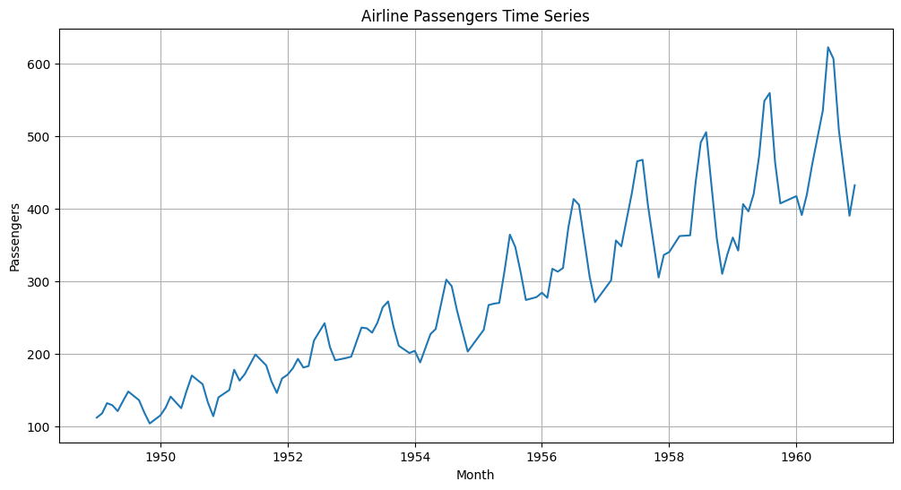  
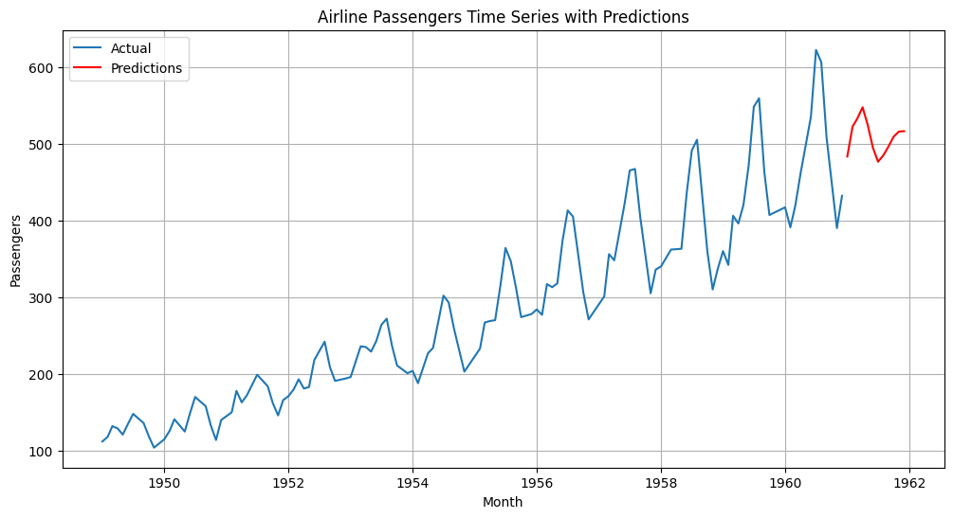  
  
  
RESULT : Thus the program has been successfully implemented.